Prophecy for 2017 from Lana Vawser, Part 2
December 11, 2016
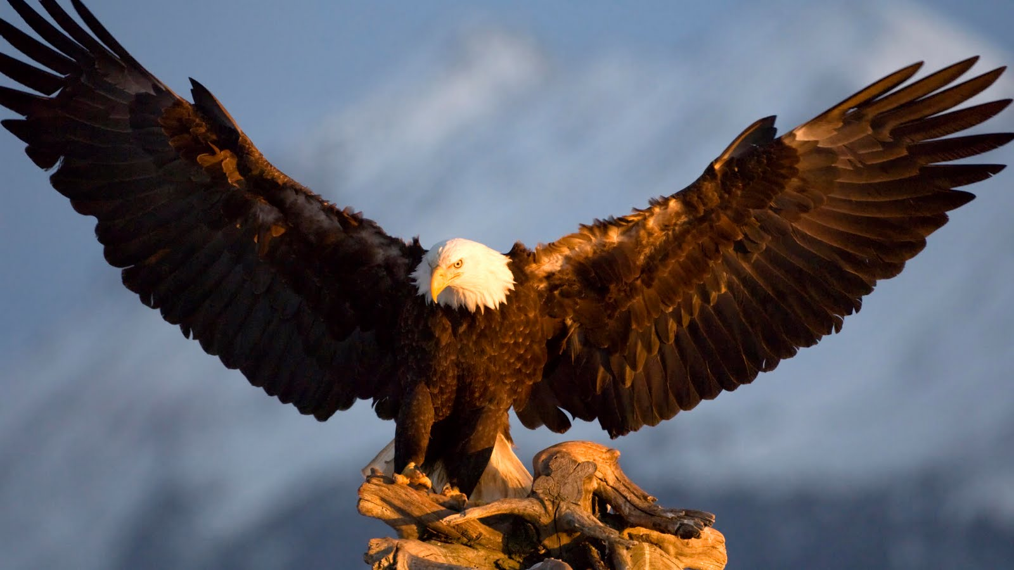
The Lord's joy be with you all, Heartdwellers.

Well, I hope you enjoyed Lana Vawser's prophecy on 2017 yesterday. And here's the second part.

God is going to cause you to REACH FOR THE SKY in 2017. He’s going to ask you to lay your dreams on the table and INCREASE them. He is going to ask you to believe for greater things that you ever have. He is going to ask you to dream things that are bigger than you ever have. He is going to ask you to do things that you never imagined possible or thought you could.

Come on, Heartdwellers! I know there's plenty of you out there with gifts and talents that you've been just a little too afraid to blossom in. If the Lord has put that deep desire in your heart, then He's calling you to that. Pay attention to it. Pay attention to it, don't settle for second best. Don't go out and get a job, for instance, just to keep a roof over your head. That's no kind of life. Get trained in what you love to do and then get a job in what you love to do. And if you're called to the mission field, don't be hanging on to a paycheck and a shallow, cushy lifestyle. Be willing to let everything go and to fly with the Lord into the mission field. He'll provide for you, every step of the way.

Lana continued:
There will be a great stretching in 2017, but it will not be like the ‘stretching’ we have felt in 2016. It is going to be a JOYFUL STRETCHING. It is going to be a STRETCHING in the “FINALLY” moments. The moments of ARRIVAL.

Wow...there's a difference, isn't there? Sometimes we don't know why we're being stretched, whether it's just an exercise in sanctity. But arriving at our destination and having to lengthen our tent pegs, spread our tent pegs out further - that's the kind of stretching that's joyful.

The lightning bolt of God’s power is going to STRIKE in 2017 and release the power of God into dreams and visions with DOUBLE PORTIONS. The things HELD AT RANSOM(boy, that's my music, guys - and Ezekiel's music, too) or HINDERED in 2016 will be released with DOUBLE PORTIONS in 2017. Where many of you have contended for so long for your own life and promises and the lives and promises of your family and those around you, and it feels like the BREAKTHROUGH STARTS but then gets HALTED or DELAYED, the Lord is going to RULE with an IRON FIST and bring the DIVINE STRIKE that will release a CLEAN SWEEP of breakthrough, heavenly justice and RE-ALIGNMENT to lead you not only into the manifestation of what He promised but into completely NEW AREAS.

Come on, Heartdwellers with talents and gifts you've been hiding and dreaming of! This is the time. This is the time to manifest.

She also said that there would be mountaintop experiences for many in 2017, because we've been in the valley for 2016.
For so long, many have been trying to “get through” 2016 and make it through alive, in 2017 you will see the FRUIT of your obedience, stewardship, prayers and “one foot in front of the other” every day to not give up, ON THE MOUNTAINTOP!!!!

Isn't that interesting, because the Lord said, "I'm taking you up higher on the mountaintop. Come on, let's go! We're going higher." And we've had to put just one foot in front of the other on some days, just make it through alive every day. This is amazing, really, what she's saying, because it so describes what we've been through!

She continues:
You have known what it is to live with the Lord in the VALLEY, but in 2017 there will be MANY MOUNTAINTOP experiences/encounters with Jesus. You will know what it is to live on the MOUNTAINTOP with the Lord. You will know what it is to have clearer INSIGHT, and heavenly encounter with Jesus than you EVER have. You will know what it is to live in a place of continual revelation and refreshing, as your roots have broken deep into places of intimacy with Him that you never imagined possible.

In 2017, there is going to be a need for heavenly wisdom and discernment more than ever. I saw the Lord opening up areas and paths to God’s people that are “foreign”. New assignments, mandates, new pathways, new tasks are going to be handed out to God’s people in this season that are COMPLETELY DIFFERENT to anything you have expected.

I'm in for surprises - I like that!

When you step into them, the feeling will arise of “I don’t know how to do this”, “I don’t know how to navigate this” but the Lord is going to give you wisdom and strategy in exponential increase.

Pay attention to your dreams in 2017, for the Lord is going to be releasing incredible prophetic insight on levels that are completely foreign and new but totally based on the Bible. KNOWING the Word and having BIBLICAL FOUNDATION will be even MORE IMPORTANT than ever in 2017 with the level of insight, revelation and encounters the people of God are moving into. Be clothed with discernment from on high! Don’t stop asking for His wisdom and discernment in ALL things based in and from His Word.

And this is so beautiful, because the deeper we get with the Lord, the more open we are about our sins. When we come to Holy Spirit and ask Him to convict us of our sin, and show us the condition of our hearts, and what's in there that shouldn't be. This engenders greater intimacy, which in turn feeds greater and greater discernment. You can really feel what is authentic and what is false the closer you get to Him.

Lana continues:
Stay in the Word!!!! So much will change in 2017, the suddenly’s that have been upon this season are not only manifesting but in 2017 there will be SUDDEN CHANGES. A SIGNIFICANT changing of GEARS will take place in areas of breakthrough that happened in 2016, but as they manifest, go deeper in My Word and you will find the WISDOM to move in and through these new FOREIGN paths.”

“See, I am doing a new thing! Now it springs up; do you not perceive it? I am making a way in the wilderness and streams in the wasteland.” (Isaiah 43:19)

And here's one of the most exciting things I've heard in a long time.

The work of UNITY amongst the people of God that is going to be seen in 2017 is going to be BREATHTAKING! In 2016 the enemy has been working hard to bring DIVISION into the body of Christ, but the work of the Holy Spirit in 2017 to bring His people together is going to cause His people to be in AWE.

Okay, I want to say something here. The one message that I gave, "There Are No Bigots in Heaven" - this would be a good time to revisit that Youtube. Because I believe that God is going to bring about unity within denominations that have been working against one another. Rather than being unified in God's Kingdom, they've been busy tearing each other apart. And I've seen this on the channel. I've seen it from Catholics and Evangelicals, just asking me to do unspeakable things, things I would never do. Asking me to give messages that God had not given me. I just wouldn't do it.

I have said everything I have to say in There Are No Bigots in Heaven, just about. And this is going to be a year of manifestation of Peace in the body of Christ. These streams are going to come together as never before, and people are going to be shocked.

I know I was shocked when I was an Evangelical and I was exploring the Catholic church. I was shocked when I sat through a Catholic mass and all they did was read Scripture. I had heard so many bad things about the Catholic church that I thought, 'they don't even use the Bible.' Nothing was further from the truth in that. And the Lord took me to that place, He took me to that church, to the inside of it - to see exactly what was of Him and what wasn't of Him. And that's going to be revealed to the whole world now. There's going to be a work of unity where God's people are going to take off their blinders and stop tearing and ripping at one another. And there's going to be an understanding and a peace between them. And they'll come together over the Truth. And this is so important, guys. This is so important. Coming together over the Truth is so important.

On the one hand, you've got the NWO trying to promote a New World religion, which we know is coming at some point. On the other hand, the Lord is going to promote His faith, He's going to bring together the different streams of faith and expose the Truth in each one of the faiths, so that we can all embrace what is True and what is false, and we can stop fighting about it.

